
学 术 报 告

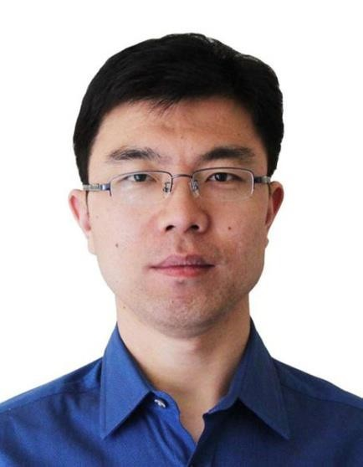
报告人：王忠良教授

报告题目：Lighting Up and Precisely Resecting Tumours

简介： 王忠良，西安电子科技大学生命科学技术学院教授、博士生导师、副院长，国家千人计划专家，中国抗癌协会青年理事会常务理事，中国医疗器械行业协会放射治疗专业委员会常务委员,中国医药生物技术协会纳米生物技术分会常务委员，中国抗癌协会整合肿瘤学分会委员。
近年来，主要从事多模态分子影像和肿瘤精确诊疗方面的研究工作，主持科技部国家重点研发计划项目等国家级项目4项。截至目前，在国际顶级期刊上发表SCI论文30余篇,包括Science, Nat. Commun., PNAS,Angew. Chem., Adv. Mater., ACSNano等国际顶级期刊，受邀在Chem. Soc. Rev. 撰写综述。多篇文章被NatureMaterials等权威期刊作为亮点报道或期刊封面，授权1项美国发明专利和2项中国发明专利，受理1项美国发明专利和6项中国发明专利，曾获省级科技进步奖一等奖1项（2017）。
报告内容：Earlydetectionplaysacentralroleingreatlyimprovingtheoutcomesofcancer treatment and increasing the overall survival. However, imaging the early stages of tumour formation in vivo remains a great challenge due to the limited sensitivity of current molecular imaging probes and the high blood background from the always-ON mode of probe design. Thus, it is urgent need to develop effective imaging probes that can help visualize the tumour development. In addition, the ability to non-invasively image the early events of tumour formation will enable reporting residual tumor cells and cancer metastases during surgical treatment. We designed and synthesized a series of new ultrasensitive NIR probes. These probes showed improved specificity and higher signal-to-background ratio. The probes can not only early detect and diagnose the cancer, but also direct the surgeons to precisely dissect the primary tumor and metastases during the surgicaltreatment.

时间：2018年4月19日（星期四），上午10:30

地点：中心实验室一楼报告厅
欢迎广大师生参加！

